**Course 12 Specialist Test 3 & Investigation 2**

Test mark ______/24 Investigation mark ______/14

Student name: ________________ Teacher name: ________________

**Task type: Response/Investigation**

**Time allowed for this task: 45 mins**

**Number of questions: 6 questions Test/ 1 question Inv**

**Materials required:** Calculator with CAS capability (to be provided by the student)

Standard items: Pens (blue/black preferred), pencils (including coloured), sharpener, correction fluid/tape, eraser, ruler, highlighters

Special items: Drawing instruments, templates, notes on one unfolded sheet of   
A4 paper, and up to three calculators approved for use in the WACE examinations

**Marks available: 24 marks Test/ 14 marks Inv**

**Task weighting: Test 6 % Inv 8%**

**Formula sheet provided: Yes**

**Note: All part questions worth more than 2 marks require working to obtain full marks.**

This first section will be recorded as test 3 in the assessment schedule.

Students decide how much time they will spend on each section, recommended 30 mins test & 15 mins Inv.

Q1 (3 marks)

Determine the equation of the tangent to  at the point .

Q2 (3 marks)

If  determine an expression for  in terms of .

Q3 (2 & 3 = 5 marks)

If  and  determine:

1.  in terms of .
2.  in terms of . (No need to simplify)

Q4 (4 marks)

Consider a metal sphere where the volume was measured and found to have an error of 5%. Use the **increments** formula to determine the **approximate** percentage error in the radius.

Q5 (4 marks)

Consider a triangle with angle  radians and opposite side length  cm, see diagram below. If the angle is changing at a rate of 3 radians/second, determine the **exact** time rate of change of when .

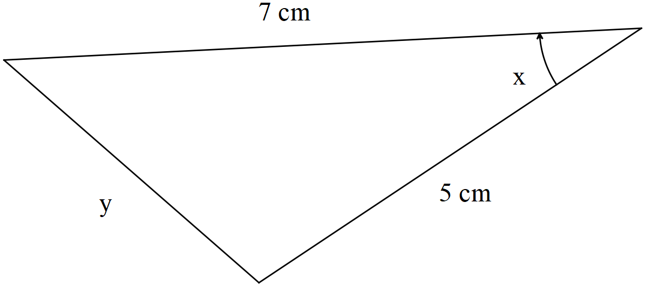

Q6 (5 marks)

Consider a car moving at metres/second towards a brick wall. On top of the car is a rotating light moving at an angular speed of  radians/second. When the light ray hits the wall a spot of light can be seen moving along the line of the wall. Determine the speed of this dot of light on the wall when the light on top of the car is 12 m from the wall and the spot of light 5 m from the central point as shown on the diagram below.

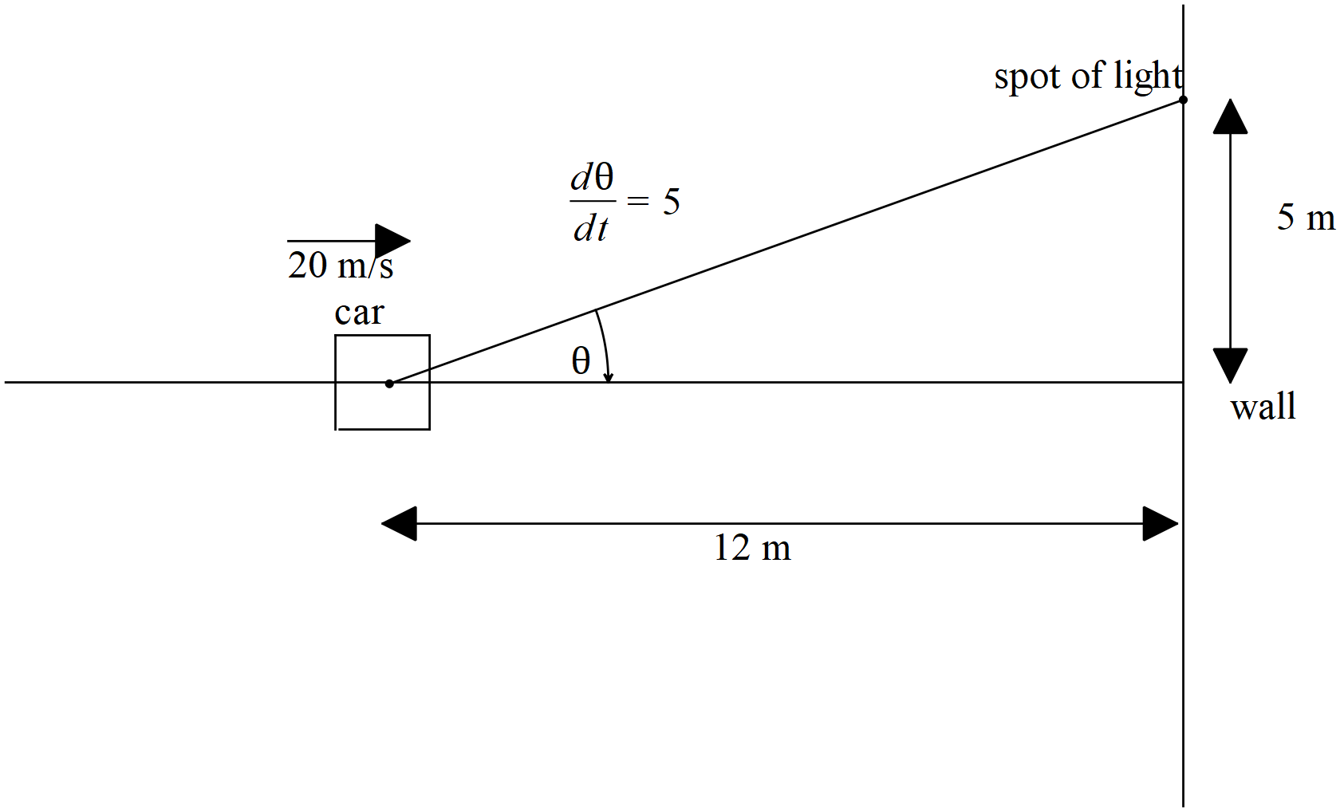

**Investigation section.**

Q1 (3, 3, 4 & 4 = 14 marks)

Differentiate the following using logarithmic differentiation. Show **all steps** in this method.

1. 
2. 
3. 
4. 